Web-Based DataMart Setup Guide

# Change Log

|  |  |  |
| --- | --- | --- |
| Changed By | Date | Changes |
| John Trussell | 5/14/2014 | Initial Revision |
| John Trussell | 5/16/2014 | Added “Set the Network Owner Organization” section, performed minor corrections and polish. |

Contents

Change Log 1

Overview 3

1 In DNS: Set the Network Owner Organization 3

1.1 Select an Organization 3

1.2 Set the Organization as Network Owner 4

1.3 Save Network Owner Organization Changes 4

2 In DNS: Generate Connection Token 5

2.1 Select an Organization 5

2.2 Open the Token Generation Popup 6

2.3 Choose a Password 6

2.4 Create the Connection Token 7

3 In WBD: Add a New Connection 7

3.1 Open the New Connection Popup 7

3.2 Specify Connection Details 8

3.3 Verify Network Connection 9

4 In DNS: Configure Data Adapters 9

4.1 Select a DataMart 9

4.2 Open the Data Adapter Configuration Popup 10

4.3 Specify Data Adapter Configuration Details 11

4.3.1 Summary Requests 11

4.3.2 DataChecker Requests 12

4.3.3 ESP Requests 12

4.3.4 Future Request Types 13

4.4 Save Data Adapter Configuration Changes 13

5 Request Initial Sync and DataSinkContact Setup and Verify Connection 13

# Overview

For each network being accessed via a Web-Based DataMart (WBD), all steps in this document (with the exception of Step 1, “In DNS: Set the Network Owner Organization”) must be performed for every organization that wishes to use the WBD to access that network. It is suggested that you completely finish configuration of one network/organization pairing before moving on to the next – it simplifies the process if you deal with a single connection token at a time, and reduces the likelihood of accidentally skipped or forgotten steps.

# 1 In DNS: Set the Network Owner Organization

This step must be performed once, and ONLY once, for a given network (not once per organization). If you are *certain* that the Network Owner has already been properly set, skip ahead to Step 2, “In DNS: Generate Connection Token”.

## 1.1 Select an Organization

Determine which organization should be the Network Owner (the administrator of the network), and click “Organizations” in the Network menu. Then, on the page listing available organizations, click the name hyperlink of that organization.

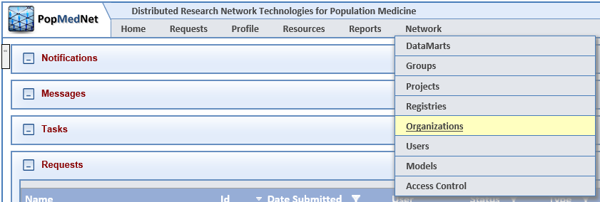

*Diagram 1.1 – Network / Organizations menu item*

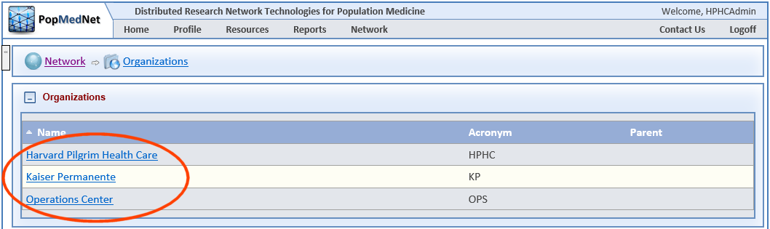

*Diagram 1.2 – Organizations list*

## 1.2 Set the Organization as Network Owner

Once you have reached an Organization’s detail page, scroll down to the “Provider Connection” section, and check the “Network Owner” checkbox.

There can be only one Network Owner per network. If another organization is already set as the Network Owner, checking this box will cause that other organization to no longer be set as the Network Owner. (Also, if the organization you have selected has already been set as the Network Owner, the checkbox will be read-only, because unchecking it would result in – at least temporarily – no Network Owner being set at all, which is not permitted.)

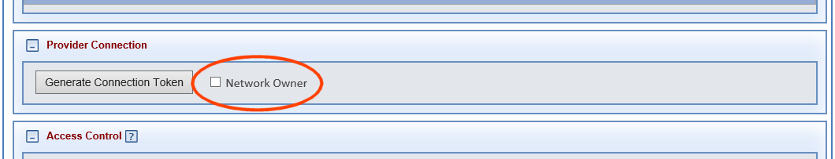  
*Diagram 1.3 – Network Owner checkbox (organization not currently set as Network Owner)*

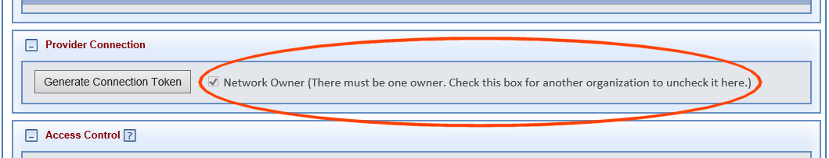

*Diagram 1.4 – Network Owner checkbox (organization already set as Network Owner)*

## 1.3 Save Network Owner Organization Changes

***After checking the Network Owner checkbox for an organization, it is critical that you scroll to the bottom of the page and click the “Save” button.***

Changes that you make on the organization detail page will not be saved permanently unless you click “Save”. Otherwise, they will be lost as soon as you navigate away from the organization details page or close your browser.

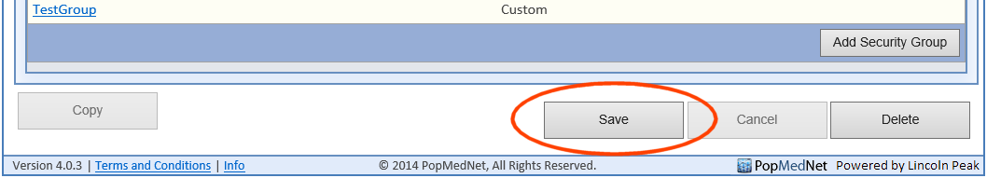

*Diagram 1.5 – Saving Network Owner Organization changes*

# 2 In DNS: Generate Connection Token

The first step in configuring the WBD to access a network is to generate a connection token. This “token” is a password-encrypted representation of all the information that the WBD requires in order to initiate the network connection.

## 2.1 Select an Organization

Connection tokens are created via the Organization detail page. To get started, click “Organizations” in the Network menu. Then, on the page listing available organizations, click the name hyperlink of an organization to be configured.



*Diagram 2.1 – Network / Organizations menu item*



*Diagram 2.2 – Organizations list*

## 2.2 Open the Token Generation Popup

Once you have reached an Organization’s detail page, scroll down to the “Provider Connection” section, and click the “Generate Connection Token” button.

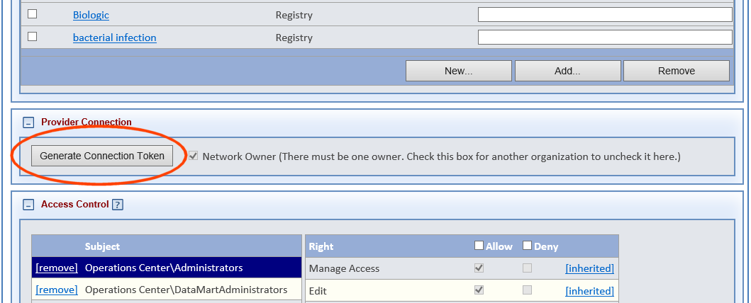

*Diagram 2.3 – Organization detail page*

## 2.3 Choose a Password

In the popup, enter a password of your choosing. This password will be used as an encryption key for the connection token, and will be used again during configuration of the WBD itself.

It is highly recommended that you use a different password for each network/organization pairing.

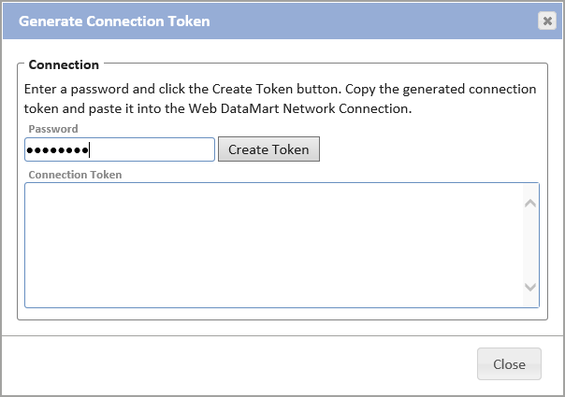

*Diagram 2.4 – Entering a connection token password*

## 2.4 Create the Connection Token

After entering the password, click the “Create Token” button. The token – a block of letters, numbers, and symbols – will appear in the “Connection Token” text box. Copy it to the clipboard or to a (temporary!) file. You will be pasting it into another text box in one of the next steps.

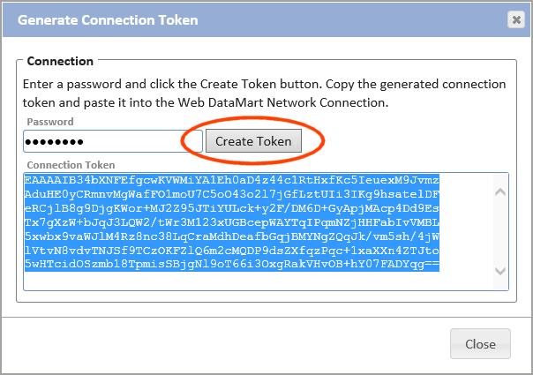

*Diagram 2.5 – A generated connection token*

# 3 In WBD: Add a New Connection

Now that you have generated a connection token in DNS, it needs to be entered into the WBD.

## 3.1 Open the New Connection Popup

Connection tokens are entered on the Add Network Connection page. To get started, click “Connections” in the Networks menu. Then, on the page listing previously-added network connections, click the “Add Connection” button. This will open the Add Network Connection page.

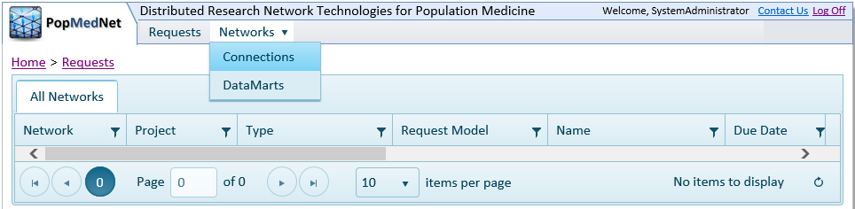

*Diagram 3.1 – Networks / Connections menu item*

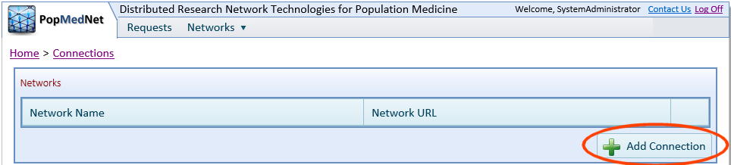

*Diagram 3.2 – Add Connection button*

## 3.2 Specify Connection Details

On the Add Network Connection page, fill in all fields with the following information:

1. **Name:** A display name of your choice for the network.
2. **Password:** The encryption password you specified in DNS (Step 2.3) when generating the connection token for this network/organization pairing.
3. **Security Token:** The token you generated in DNS (Step 2.4) for this network/organization pairing.

Once all fields have been filled in, click the “Connect To Network” button.

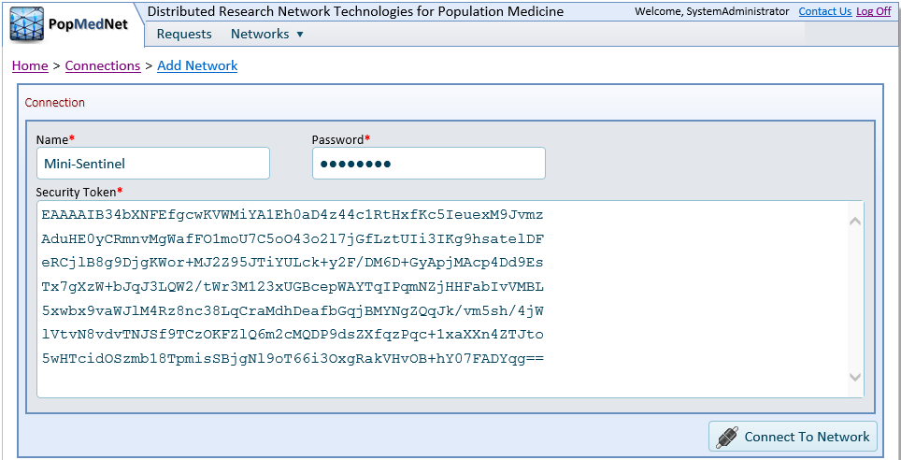

*Diagram 3.3 – Network connection details*

## 3.3 Verify Network Connection

A few moments after clicking “Connect To Network”, if the connection was successful, the Connections list page will appear. Verify that the new network connection appears in the list, and that the Network URL is correct. (Also, if you copied the token to a file in Step 2.4, delete it now.)

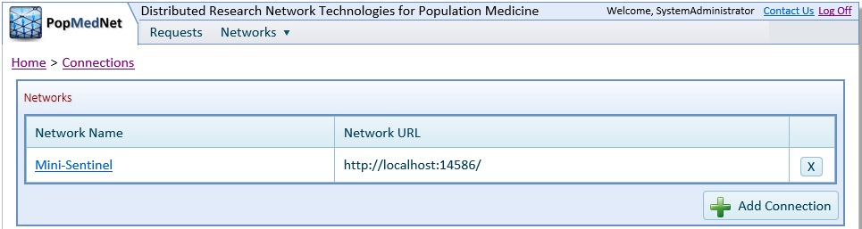

*Diagram 3.4 – Network connections list*

# 4 In DNS: Configure Data Adapters

At this point, the connection has been made between WBD and DNS for the specified network/organization pairing. However, the data adapters for most request types require additional configuration before the WBD will be able to process requests.

This configuration process closely mirrors that of the desktop DataMart Client.

For each network being accessed via the WBD, the steps in this section must be performed for every DataMart associated with every organization that wishes to use the WBD to access that network.

## 4.1 Select a DataMart

Click “DataMarts” in the Networks menu. Then, on the page listing available organizations, click the name hyperlink of a DataMart with data adapters to be configured.

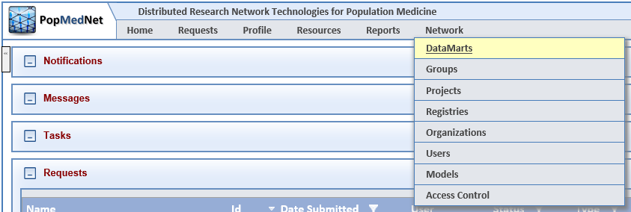

*Diagram 4.1 – Network / DataMart menu item*

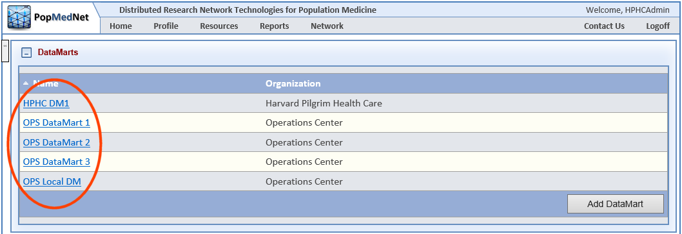 *Diagram 4.2 – DataMarts list*

## 4.2 Open the Data Adapter Configuration Popup

Once you have reached a DataMart’s detail page, scroll down to the “Installed Models” section, and click the “[configure]” hyperlink for a specific request type. (Note that a few request types do not have a “[configure]” link. Those request types do not require additional configuration.)

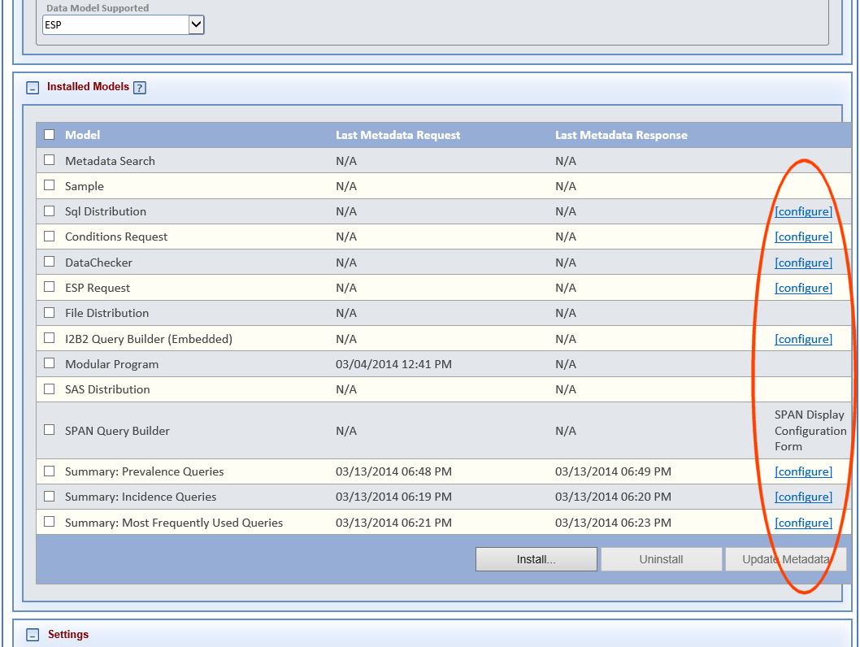

*Diagram 4.3 – Data Adapter configuration links*

## 4.3 Specify Data Adapter Configuration Details

The configuration popup for the selected data adapter will appear. The configuration parameters that need to be specified will depend on the request type.

### 4.3.1 Summary Requests

The Data Source for Summary requests may be either a SQL Server database or an ODBC data source, and the configuration parameters requested will change based on the Data Provider selection.

*Note: For SQL Server databases, “User ID”, “Password” and “Confirm Password” are only required if SQL Server Authentication is being used. If using Windows Authentication, those fields may be left blank.*

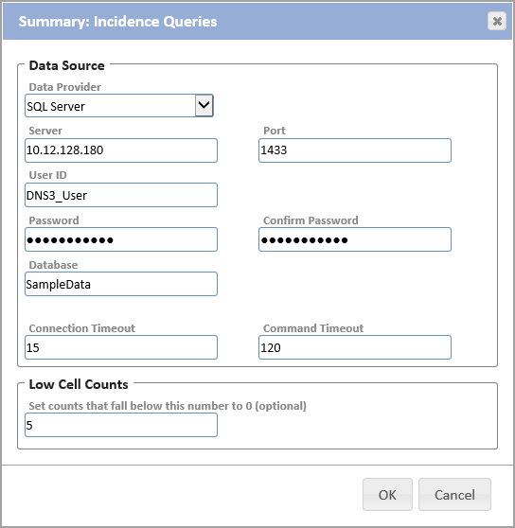

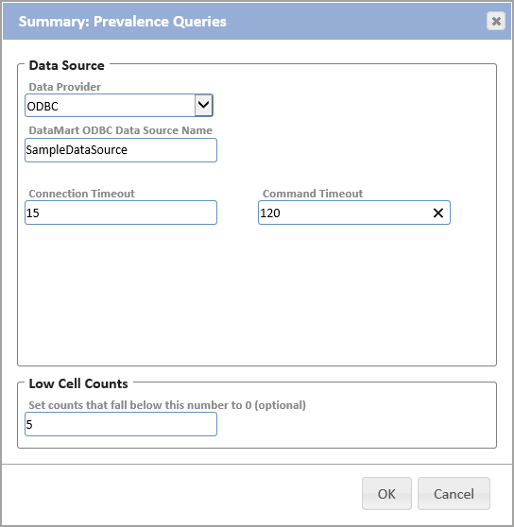

*Diagram 4.4 – Summary Query Configuration (SQL Server Database & ODBC Data Source)*

### 4.3.2 DataChecker Requests

The Data Source for DataChecker requests may be either a SQL Server database or an ODBC data source, and the configuration parameters requested will change based on the Data Provider selection. The parameters are the same as for Summary requests, except that the DataChecker configuration popup does not contain a “Low Cell Counts” section.

*Note: For SQL Server databases, “User ID”, “Password” and “Confirm Password” are only required if SQL Server Authentication is being used. If using Windows Authentication, those fields may be left blank.*

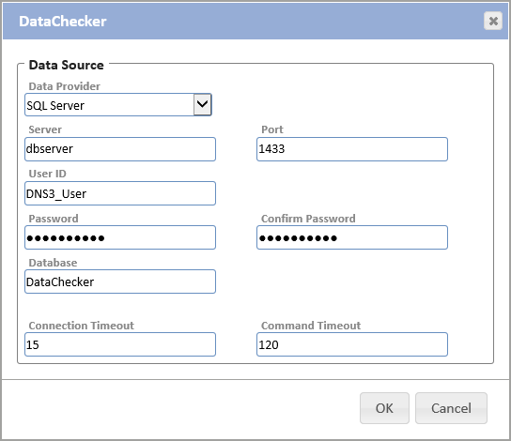

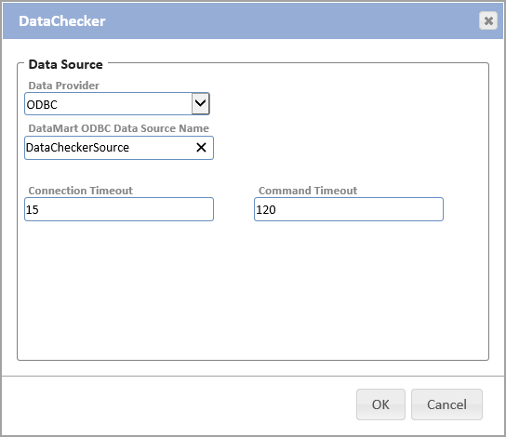

*Diagram 4.5 – DataChecker Query Configuration (SQL Server Database & ODBC Data Source)*

### 4.3.3 ESP Requests

Currently, the Data Source for ESP requests must be a PostgreSQL database. The configuration popup contains fields for parameters required to access that database.

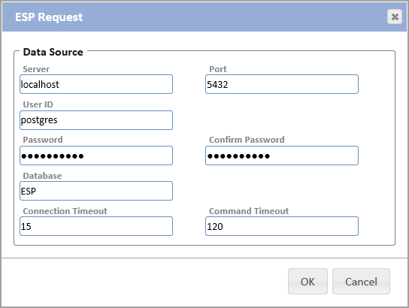

*Diagram 4.6 – ESP Query Configuration*

### 4.3.4 Future Request Types

As time goes on, additional data adapters will be added in order to support new request types. The configuration popups for those data adapters will be accessed in the same manner as those currently included. The configuration parameters requested in those popups may differ from those shown above. This document will be revised in the future to include those new popups.

## 4.4 Save Data Adapter Configuration Changes

***After setting the configuration parameters for all data adapters, it is critical that you scroll to the bottom of the page and click the “Save” button.***

Changes that you make in each configuration popup will be remembered as you work your way through the rest, but will not be saved permanently unless you click “Save”. Otherwise, they will be lost as soon as you navigate away from the DataMart details page or close your browser.

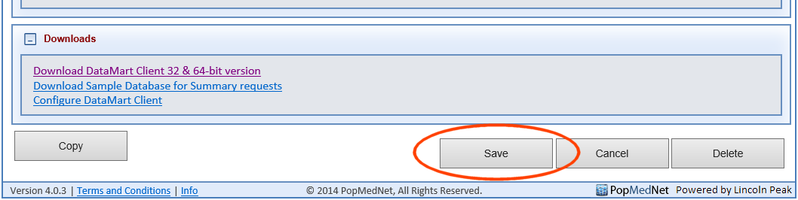

*Diagram 4.7 – Saving Data Adapter Configurations*

# 5 Request Initial Sync and DataSinkContact Setup and Verify Connection

After all of the above steps have been completed, two steps remain that must be performed by the Lincoln Peak Managed Services team. Contact them, and request the following:

* An initial sync of requests between DNS and WBD. This can take up to an hour, and will be run after normal business hours to avoid negative impact on other users of the system.
* Association of the Data Sink Contact with the appropriate DataMarts.

Upon notification that these final steps have been completed, verify that the connection works by running a request end-to-end (entering it in DNS, running the query in WBD, and uploading results back to DNS).